**DAILY ONLINE ACTIVITIES SUMMARY**

|  |  |  |  |  |  |  |  |
| --- | --- | --- | --- | --- | --- | --- | --- |
| **Date:** | **12 June 2020** | | | | **Name:** | **K ISHA HEGDE** | |
| **Sem & Sec** | **4th sem, 2nd year** | | | | **USN:** | **4al18cs031** | |
| **Online Test Summary** | | | | | | | |
| **Subject** | | **--** | | | | | |
| **Max. Marks** | | **--** | | **Score** | | **---** | |
| **Certification Course Summary** | | | | | | | |
| **Course** | **PYTHON** | | | | | | |
| **Certificate Provider** | | | **GUVI** | **Duration** | | | **6 hours** |
| **Coding Challenges** | | | | | | | |
| **Problem Statement:1 program** | | | | | | | |
| **Status: Executed** | | | | | | | |
| **Uploaded the report in Github** | | | | **Yes** | | | |
| **If yes Repository name** | | | | **[https://github.com/iishaii/locked-down_coding](https://github.com/iishaii/locked-down_coding" \o "https://github.com/iishaii/locked-down_coding)** | | | |
| **Uploaded the report in slack** | | | | **Yes** | | | |

**Certification Course Summary:**

Today I continued with the PYTHON course and completed the advance module. I attempted quiz after each topic which gave me clear veiw about the topic.It took me about 6 hours to complete that module.

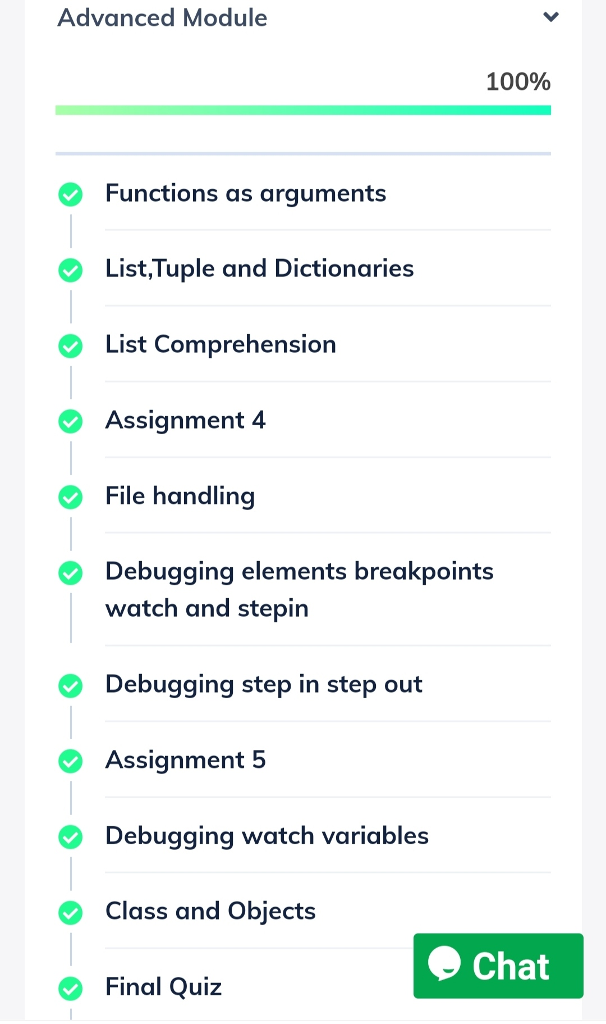

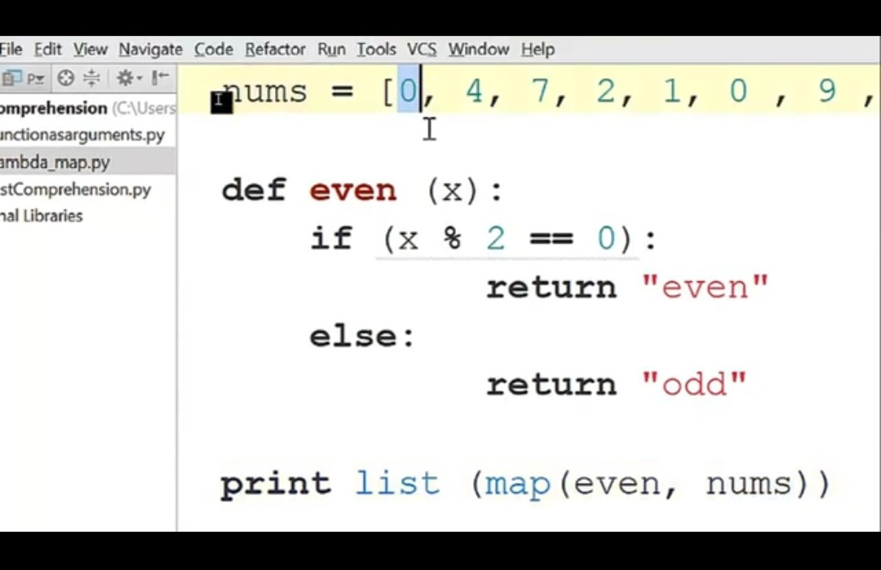

QUIZ:

I attempted quiz on OPERATING SYSTEM on 6th JUNE .I secured 96%. There was a delay in the delivery of the certificate .



**WEBINAR:**

**I had attended webinar on E COMMERCE on 8th June and also received the certificate.**



**Coding Challenges:**

Today I solved coding challenge,

1. **Given two positive integers start and end. The task is to write a Python program to print all Prime numbers in an Interval.**

**Explanation: A prime number is a natural number greater than 1 that has no positive divisors other than 1 and itself. The first few prime numbers are {2, 3, 5, 7, 11, ….}. The idea to solve this problem is to iterate the val from start to end using a for loop and for every number, if it is greater than 1, check if it divides n. If we find any other** number which divides, print that value

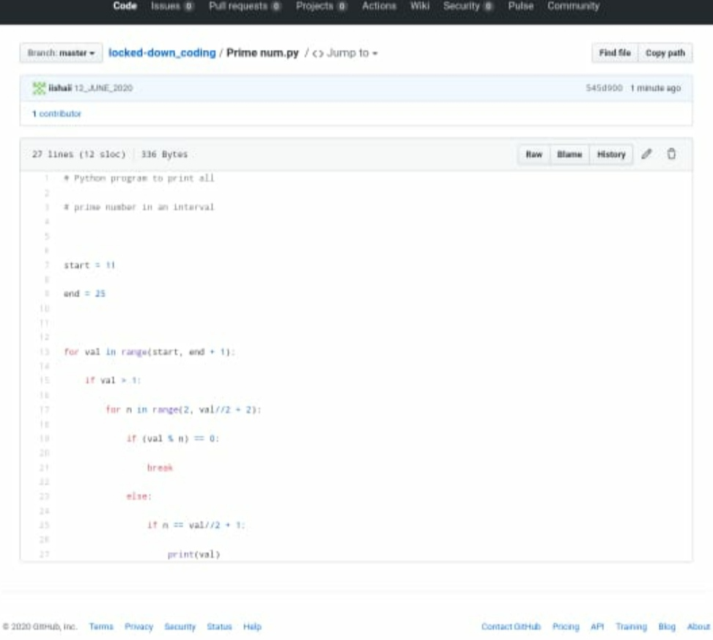

I have uploaded the solution in my GitHub

[https://github.com/iishaii/locked-down_coding](https://github.com/iishaii/locked-down_coding" \o "https://github.com/iishaii/locked-down_coding)

I have attached the snapshot below:

